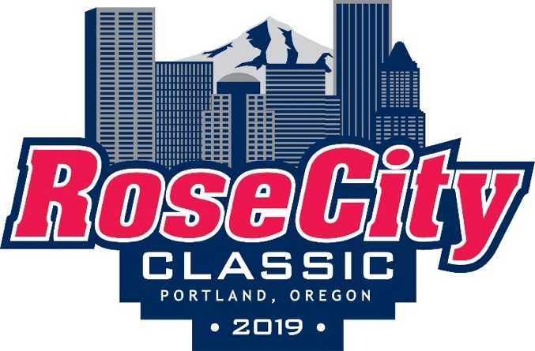
We are thrilled to welcome you to the Rose City Classic, our second annual all-girls ice hockey tournament in Portland, OR February 16-18, 2019. We are excited to continue a tradition of growing and supporting girls hockey in the region with teams from Northern California, Washington, and British Columbia.
In preparation for the tournament please email me team rosters by Feb. 8th . Attached you will find the latest schedules for each division and the tournament rules. Please keep in mind we are playing USAH rules most notable difference is automatic offsides (players can not tag up) and icing rule remains in effect even during a penalty kill.
Here are some quick things to know:
- 8U/10U division will be playing in a half-ice round robin format.
- 12U will be playing in a “cross pool” format, with semi finals, finals and a consolation game.
- Games will be played at Sherwood Ice Arena (SIA) [20407 SW Borchers Dr, Sherwood, OR 97140] and Winterhawks Skating Center (WSC) [9250 SW Beaverton Hillsdale Hwy, Beaverton, OR 97005]. Make sure to check your schedule for location.
- Each team is responsible to supply a person for the penalty box for their own team during their games.
- Team coaches must check in at the Rose City table before each game to verify and sign scoresheets.
- During the tournament weekend, the Portland Jr Winterhawks are also hosting a 10U youth tournament, so the rinks will be full of amazing hockey energy. To accommodate this, there will be separate check-in tables for each tournament, so please look for the red Rose City Hockey Club table and banner.
- Locker rooms will be available to teams 45 minutes before each game and 20 minutes after each game, with the exception of games played before and after the 8U/10U games.
- Locker Room access at WSC: Since the 8U/10Us are playing half ice, there will be 4 teams on the ice at once. Since the rink only has 4 locker rooms, we’ll need to be flexible. Specifically, when your team is playing before or after the 8U/10Us and all 8U/10U teams, please have your team fully dressed out 15 min before your ice time, collect all gear bags and put them outside the locker room the designated gear area. This will allow the younger players to come off the ice and use the locker rooms again. We appreciate your understanding.
Finally, if you are coming from outside the Portland area, we’ve put together a list of local things to do, including options for food near the rink. Passes for the Columbia Company Store and adidas Company Store will be available at the Rose City table. Again, we are excited to host your team and welcome to the tournament.
Regards,
Robin Willins
Some things to do:
- Powell’s City of Books
  - 1005 W Burnside St, Portland, OR 97209
  - www.powells.com
- Oregon Museum of Science and Industry
  - 1945 SW Water Ave, Portland, OR 97214
  - www.omsi.edu
- Cinetopia (Progress Ridge)
  - 12345 SW Horizon Blvd, Ste 231, Beaverton, OR 97007
  - www.cinetopiatheaters.com
- Washington Square Mall
  - 9585 SW Washington Square Rd, Portland, OR 97223
  - www.shopwashintonsquare.com
- Bullwinkle’s Family Fun Center
  - 29111 SW Town Center Loop, Wilsonville, OR 97070
  - www.fun-center.com
- Super Play (next to WSC ice arena):
  - 9300 SW Beaverton-Hillsdale Hwy, Beaverton, OR 97005
  - www.superplayor.com
- Sky High Sports
  - 11131 SW Greenburg Rd, Tigard, OR 97223
  - www.por.skyhighsports.com
- Top Golf
  - 5505 NE Huffman St, Ste 2, Hillsboro, OR 97124
  - www.topgolf.com
- K1 Speed Go Cart Racing
  - 5579 NE Huffman St, Hillsboro, OR 97124
  - www.k1speed.com
Restaurants near the rink:
- Olive Garden 11650 SW Canyon Rd, Beaverton, OR 97005
- Pastini Pasterria 3487 SW Cedar Hills Blvd, Beaverton, OR 97005
- Cheesecake Factory 9309 SW Washington Square Rd, Tigard, OR 97223
- Stanford’s Restaurant & Bar 2770 NW 188th Ave, Hillsboro, OR 97124
- Red Robin 4105 SW 117th Ave, Beaverton, OR 97005
- BG Food Cartel (Food Cart pod) 4250 SW Rose Biggi Ave, Beaverton, OR 97005
- Other restaurant’s nearby Chipotle, Noodles & Co, Hawaiian Time, Jersey Mikes, Pizzicato, Chik Fil-A, Panera, Subway

